I’m looking for a Personal Assistants (Female*)
Hours: 2 x 15 hrs plus occasional sleepover
Salary: £16,731 (£8.25 per hour, sleepovers £64.80)
Job Reference: PA/SA/04/17
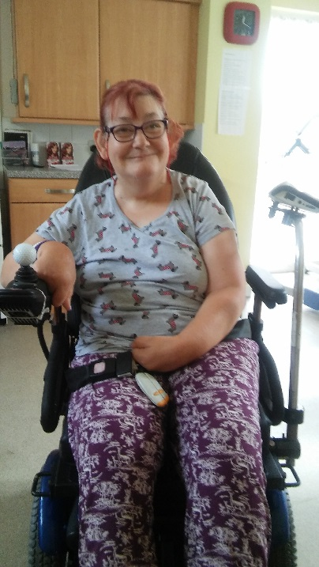
My name is June I am 63 years old and I live in the Craigmillar area of Edinburgh. As you can see I use a wheelchair so need your support to help me with housework, dinner, lunch, bathroom, going out, food shopping, clothes shopping and getting to bed at night as I find it difficult to do this myself.
I’m looking for someone to join my Team, who is able to support me any day of the week as part of the Rota and is confident, relaxed, likes to laugh, is outgoing and a positive person who can encourage me to try new things. I love home cooked food and so it would be great if you are a good cook, I like to do as much for myself as I can so need you to be patient with me as some things can take me a while. I like to be social but also like time to myself; I don’t like it someone talks too much too me. I can be a bit of a worrier and would like it if you help me to be more positive. I’m not really a morning person and so it is important to me that you are not too bubbly at this time of the day as it could make me annoyed. I have recently made a trip to a local shop for the first time on my own and would love to do more of this and be more confident in it. My verbal communication can be hard to understand but If you’re patient, in time you’ll soon get to know what I’m saying. I also have a lite writer to help me with how I communicate.
My Support hours are;
12 noon till 5pm – to have my lunch, maybe a shower, go shopping, do some housework, go out and about and have my dinner.
9pm till 11pm with a sleepover then 7am till 10am – to have my supper, bed (sleepover - with you sleeping in a room in my house as I feel safer with someone here), support me to get up in the morning, use the bathroom, get dressed and help me with my medication.
If you’re interested in coming to be part of my Team (who are like my family) I would really like to see your application. If this looks good to me I think I would like to meet you at the interview. I would also like to see you supporting me as part of you possibly joining my Team so that it helps me decide if you’re the one I’m looking for. Don’t worry one of my Team will be there to guide you as well as myself.
I hope you want to make a difference in my life and support me to have the best life I can; if this is you then please apply!
Closing Date for Applications : Friday 12th May 2017
*Exemption under Equality Act 2010

